Ultrasonic Disaggregation for Smear Slide Preparation.
Rocks that are too lithified for disaggregation by standard smear slide methods (Marsaglia et al., 2013, IODP Report) may in some cases be effectively disaggregated by use of a probe sonicator (e.g., the Qsonica Q700, Figure 1). This methodology works best for sediments which have been consolidated primarily by compaction, but not as well for those lithified by cementation¹. Ultrasonic disaggregation following the protocols described here is believed to yield particles that are representative of the natural particle-size distribution in the rock. Rigid particles (e.g., quartz, feldspar, carbonate grains including fossils, and most lithic fragments) released from mudrocks using these protocols also display a range of surface textures that seem to reflect the natural range of surface types observed on silt particles from modern, unconsolidated sediment (Land & Milliken, 2000; Milliken, 1992).Thus, sonic disaggregation does not appear to either break many silt particles or to cause modifications to grain surfaces. Unintended disaggregation of natural clay-rich aggregates (pellets, peloids, rip-up clasts, and possibly some mudrock lithic clasts) is, however, a possibility.
The quantity of material needed for processing in the sonicator is small, but larger than the standard “toothpick” sample used for smear slides. An amount corresponding to about 0.5 cm³ should be adequate (around 3 to 4 4-mm-sized cuttings pieces). This methodology is highly recommended for lithified cuttings but sampling from core may require use of the working-half of the core rather than the standard archive half.
Unless you resort to centrifugation, it is not practical to capture all of the clay-size material that is released during sonication. Thus, clay-size components may be underestimated in samples prepared as described in these instructions. The missing clay will be the finer material, a component that is poorly estimated in smear slide observation in any case.

References
Land, L. S. and Milliken, K. L., 2000, Regional loss of SiO₂ and CaCO₃, and gain of K₂O during burial diagenesis of Gulf Coast mudrocks, USA: in Worden, R. H. and Morad, S. (eds.), Inter-national Association of Sedimentologists Special Publication No. 29, Quartz Cementation in Sandstones, Blackwell Science, 183-198.
Milliken, K. L., 1992, Chemical behavior of detrital feldspars in mudrocks versus sandstones, Frio Formation (Oligocene), South Texas: Journal of Sedimentary Petrology, v. 62, 790-801.
¹Extraction of sedimentary particles from cemented rocks requires additional chemical methods to remove or partially remove the cement. In the case of overgrowth cementation, in which the cement forms by nucleating upon and extending the crystal lattice of the underlying grain, removal of cement with preservation of the grain and grain surface may not be possible.

Figure 1. The Qsonica Q700 ultrasonic probe disaggregator.

OPERATION OF PROBE SONICATOR
Safety:
There are two main safety considerations for operation of ultrasonic disaggregators (beyond the precautions that apply to any electrical equipment):
- The sonic pulse produced by the instrument is above the range of human hearing, however, cavitation effects within the suspension produce potentially harmful levels of noise at lower frequencies. Smaller containers and glass containers tend to produce louder sounds. Enclosure of the device within the box should obviate this issue. If the sonicator is operated outside its enclosure, then hearing protection may be advised. Use sound judgment: if the sound is at all unpleasant, use protection.
- NEVER TOUCH THE SONIC PROBE IN OPERATION. Operation of the unit within the enclosure should prevent any potential for contact with the probe, but operation outside of the box would make it possible for you to, say, put your finger in the suspension to, say, pluck out something you accidently dropped into it. Why is this dangerous? Because the probe is designed primarily as a cell disrupter. The greatest danger from a pulse that travels through your tissues is to your retina—a highly delicate and important group of cells. DO NOT TOUCH AN ACTIVE SONIC PROBE!!!
Additional precautions relate to potential damage to the instrument and samples.
- Do not allow sonication to proceed unattended for more than a few minutes. The sonic pulse transmits considerable energy to the suspension and causes heating, possibly to the point of boiling. The smaller the volume, the greater the potential for rapid heating. Boiling liquids while under sonication can cause significant cavitation effects, possibly leading to breakage of the sonication vessel.
- NEVER allow the probe to operate in air. Without a surrounding liquid to carry heat away from the probe it will rapidly overheat causing damage to the electrical components and possibly welding the probe tip to the horn.
- Do not allow the active probe or tip to touch a glass container. Be aware that glassware may have flaws that lead to breakage under sonication. Do not leave the sonicator unattended while sonicating in glass. If the beaker breaks, turn off power immediately---see 2, above.
- The sonicator tip is an expendable component. Check the tip daily for topography arising from wear. Once the tip develops a distinct rim, it must be replaced. Allowing a tip to wear to the point that the corrosion topography extends up the sides will cause damage to the horn. Microns of change in the horn length affect its resonance frequency and cannot be repaired.
- See general operation cautions on p. 5 and p. 14 of Q700 operation manual.

General operation of the ultrasonic probe disaggregator (Qsonica Q700):
Materials:
30 ml beaker, distilled water, glass rod or other small tool for stirring and disaggregation, pipette
Standard materials for smear slide preparation: glass slide, optical adhesive, hot plate, UV oven, labels
Procedure:
- Place some small fragments of rock in the beaker. (Up to 10% of volume of beaker).
- Fill beaker about half-way with distilled water.
- Place beaker on foam block.
- Lower probe into beaker until it is a few mm off the bottom. Do not allow probe or tip to touch the glass! (Figure 2 A).
- Close the door of the sonicator enclosure.
- Power on the sonicator unit. Select the manual option. Set the amplitude to 30. See interface operation instruction on p. 15-17 of Q700 manual.
- Start the sonication.
- Watch specimen for signs of disaggregation. If the rock does not disaggregate, try higher amplitude settings.
- Do not sonicate for longer than 2 minutes.
- Turn off sonicator and check specimen (you do not have to reduce power level once you have established it).
- If undisaggregated pieces remain, attempt to gently mash them against the side of the beaker. Let cool briefly and sonicate again.
- Proceed until there is enough disaggregated material for a smear slide.
- Remove any undisaggregated pieces and discard.
- Clean the probe with clear water and a lab wipe.
- Depending on how clay-rich your sample is:
  - Stir sample vigorously with the pipette and obtain a sample of the suspension while the suspension is still in motion (best for very clay-rich materials).
  - Alternatively, let suspension settle for about 5 minutes, and suction a sample of the sediment off the bottom of the beaker with the pipette.
  - Alternatively, for a concentrated silt sample, let the sample settle, decant the clay-rich suspension into the sink, re-suspend the silt-fraction with the sonicator, settle, and after a few repetitions take the sample from the bottom of the beaker.
- Apply the suspension to the smear slide glass and complete the slide in the usual manner.
ATTENTION:
- Never leave the sonicator unattended while in operation.
- Do not let the suspension boil.
- Be aware that the beaker and liquid may become hot.
- Turn off immediately if the beaker breaks.
- NEVER Touch an active sonic probe.
- 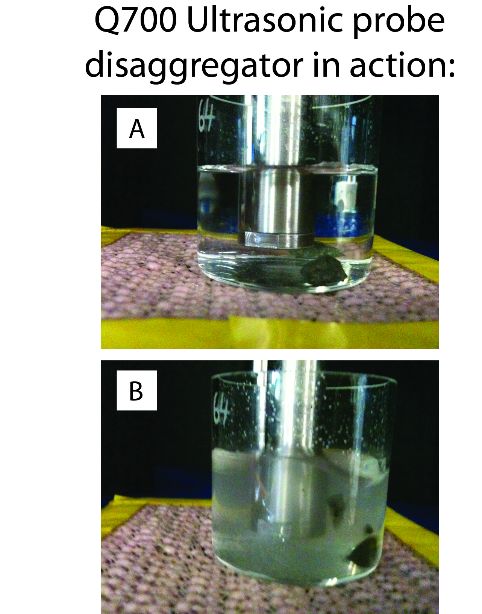

Figure 2. A. Proper placement of probe tip relative to bottom of beaker.
B. Turbulence in beaker during sonication.

