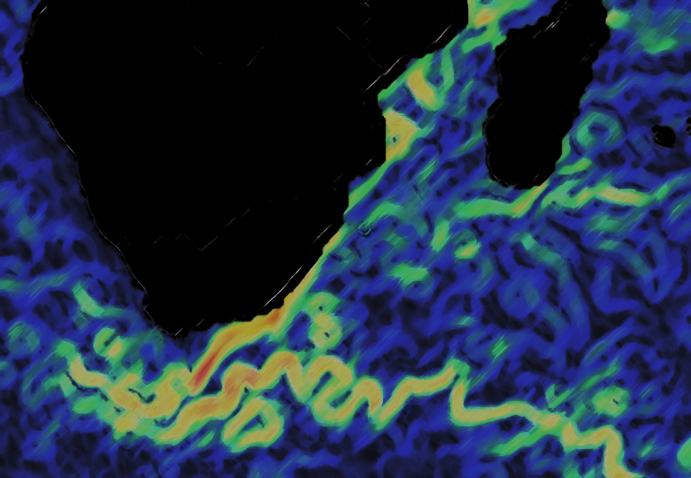
Exp 361
Tech Reports
Southern African Climate
Agulhas Current Density Profile

PHYSICAL PROPERTY LAB
MarGARET Hastedt, NICOLETTE LAWLER and Alexis ARMSTRONG

P-Wave Logger (PWL) Equipment
The PWL system consists of two 1” diameter, 0.5MHz piezoelectric transducers from Olympus (model M2008) with the following characteristics:
- Central Frequency: 0.48 MHz
- Peak Frequency: 0.07 MHz
- -6DB Bandwidth: 75.42%
Both transducers are protected by a stainless steel delay-line cap. Propylene Glycol or Glycerin is used as a couplant between the piezoelectric element and cap and should be renewed weekly.
The transducers are driven by an Olympus Pulser-Receiver (model 5077PR). Vendor’s description:
The Model 5077PR provides square wave excitation with a fast pulse rise and fall time. The pulse voltage and pulse width are adjusted directly to provide precise control over pulse shape. By tuning the period (pulse width) of the square wave to half that of the transducer center frequency, pulse energy to the transducer at its natural resonant frequency is increased.
For P-Wave Logger, we set the Pulser-Receiver to produce a -200 V square wave for 1 µsec (0.5 MHz), at 200 pulses per second. The return signal is amplified as necessary by the pulser to overcome signal attenuation (-50 to 50 dB).
A single linear variable-displacement transducer (LVDT) measures the distance between the transducers as a voltage output. The thickness of the core liner is doubled and then subtracted from the LVDT value (converted to mm) to give the thickness of the core material within the liner.
Signal digitization is performed by a National Instruments high -speed 8-bit digitizer (model NI-USB 5133). The digitizer has two channels, Channel A is connected to the Pulser-Receiver to capture the waveform and Channel B to the LVDT to capture the voltage changes related to the distance between the transducers. Both channels capture data at a 100 MS/sec (Δt = 50 ns) and are triggered by the timing signal from the pulser-receiver. Channel A’s range is set to +/- 1 v and Channel B is set to +/-5 v.
The transducers are mounted in a caliper system, which is driven by a Tritex rotary-liner actuator (model TLM20). Acoustic coupling to the core liner and the material inside is enhanced by a water drip system. Both the actuator and water pump are controlled by the IMS track software, which coordinates the closing and opening of the transducers as the core is moved from one measurement position to the next. Spring loading of the caliper ensures a consistent contact pressure; although, the actuator can be set to compress the liner so that contact is made between the liner and the material within.

SIGNAL PROCESSING
Figure 2 summarizes the following signal processing discussion.
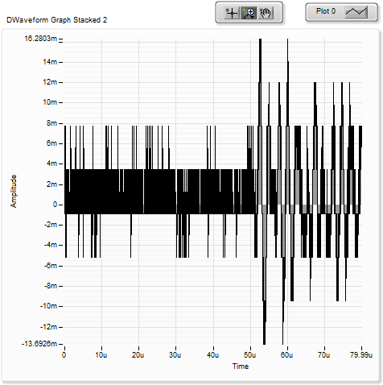
Acquisition and Ensemble Averaging: The received waveform is digitized at 10 nsec intervals and collects a record 60 µsec long. The first 10 µsec of the waveform is replaced with zeros to remove a large spike that occurs at the beginning of the outgoing pulse. We believe that electrical “cross-talk” within the pulser-receiver to be the source of this noise.
Figure 1
A Butterworth Bandpass filter is then applied to the waveform to reject frequencies less than 0.4 MHz and above 1.0 MHZ. This bandpass-filtered waveform is then stacked, summed and averaged (ensemble averaging). The size of the stack is a value between 10 and 100 as selected by the user.
Even with this initial filtering and ensemble averaging, the resulting signal can still contain significant noise generated by the shipboard environment. Figure 1 is typical of the signal quality.
Picking the 1st Arrival: Past attempts to use a cross-correlation method (popular in seismic analysis) have not been successfully applied to our data. Coefficients developed for one type of lithology would fail when the lithology changes. Therefore, we still depend on a threshold crossing process to determine first arrival time. The weakness of this method is that any high-amplitude noise can cause a false pick.
To increase the likelihood of a correct pick, the P-Wave Logger software on the Whole Round Multisensor Track (WRMSL) uses a series of mathematical and data manipulation techniques to suppress the noise relative to the peak of the first arrival. Another goal is to eliminate the constant adjustment of the threshold value as the amplitude of the waveform changes due to variation in signal attenuation along the core. The P-Wave Logger is an automated system and constant supervision and adjustment is not practical.
Signal to Noise Ratio (SNR) Enhancement: Methods employed are based in part on Dr. Tom O’Haver’s 2006 publication: A Pragmatic Introduction to Signal Processing
(http://terpconnect.umd.edu/~toh/spectrum/IntroToSignalProcessing.pdf).

The ensemble averaging done at the acquisition stage is effective at eliminating nearly all of the random noise. Unfortunately, our signals contain a great deal of systematic environmental noise that cannot be fully eliminated by shielding signal cables. To suppress this noise, we need to exploit small differences between the noise and the acoustic pulse. The parameters used in the smoothing operators were developed empirically measuring a variety of materials and by degrading the signal by attenuation at the pulser-receiver. Time was limited on Expedition 361 to select the best smoothing operators and their parameters. Further experimentation is needed to improve the process and validate that it will work for all possible lithologies recovered by IODP.
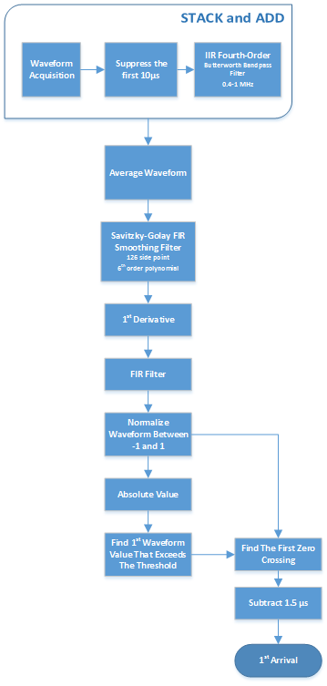
Figure 2

The SNR enhancement process consists of three steps: 1) smoothing, 2) 1st derivative, and 3) smoothing. The first smoothing step passes the waveform through a Savitzky-Golay filter that applies a polynomial least square fit step-wise through the data (similar to a running average). Experimentation shows that using a 6th order polynomial across a 126 data points will reduce high-amplitude, high-frequency noise while retaining the shape of the acoustic pulse.
After the first smoothing operation, we then take the 1st derivative (central-difference), which suppresses the low-frequency noise. The downside to the differentiation is that the process adds back in high-frequency noise. This is why we run a second smoothing step. A FIR operation is used in the second smoothing pass. The FIR filter coefficients were calculated using LabVIEW tools.
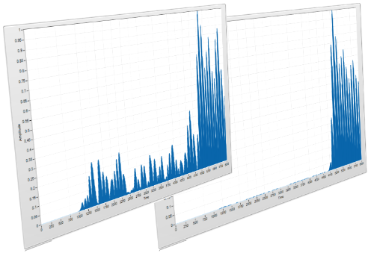
Figure 3 shows the waveform (as absolute values) before and after the third step process and illustrates the significant noise suppression that was achieved. Attempting to find the first arrival on the un-processed data would have failed because the amplitude of the noise is greater than of the first arrivals peak.
Figure 3

Normalization: At this point in the process, a copy of the waveform is normalized so that the waveform is scaled between the values of -1 and 1. A second copy of the processed waveform is converted to its absolute value and then normalized with the waveform scaled between values of 0 and 1. This normalization is critical to making the threshold picking process indifferent to either amplification or attenuation of the signal. Experience has shown that the threshold value needs little adjustment once chosen unless there is a significant lithology change.
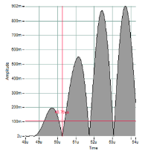
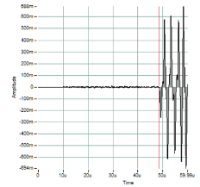
1st Arrival Time: The threshold crossing is performed on the absolute copy of the waveform. The crossing time is then used as the starting point to find the first zero crossing in the derivative waveform. From this time value, we subtract 1.5 µ to account for ¼ wavelength phase shift caused by the 1st derivative operation, and ½ wavelength correction back to the first arrival. See Figure 4.
Figure 4. The left-hand graph shows the threshold (Horizontal cursor) crossing the first peak of the acoustic pulse and the 1st zero-crossing (vertical cursor). After correcting the time, the right-hand graph shows the pick on the original stacked waveform.

Waveform Data: The process described above greatly distorts the original waveform. Any time shifts artificially induced are eliminated by the P-Wave calibration and rolled into the system time delay value. The waveform that has been band-pass filtered and ensemble averaged is saved for post-cruise studies and the processed waveforms are discarded after the 1st arrival.

