Meth-A_Intro+Ops_

Supplementary Data: Breakdown of Hours

Week 1: No core recovered
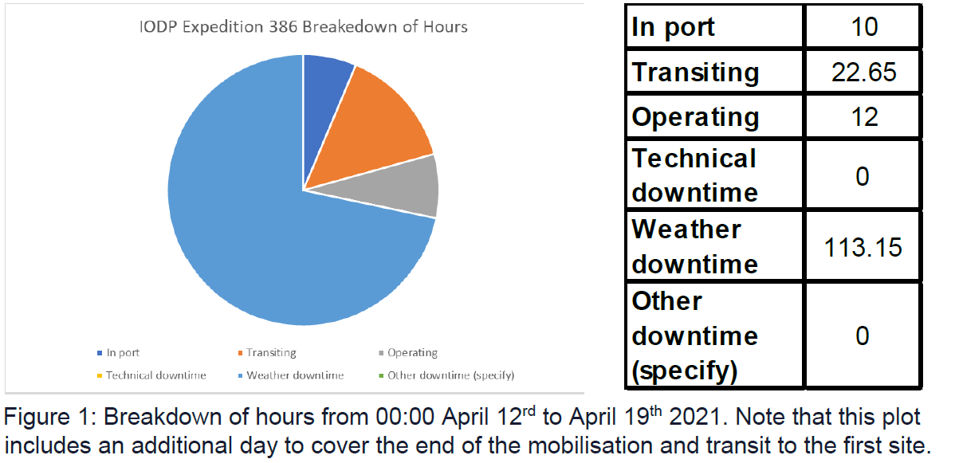

Week 2: Holes M0081A-D, 82AB, 83AB, 84AB
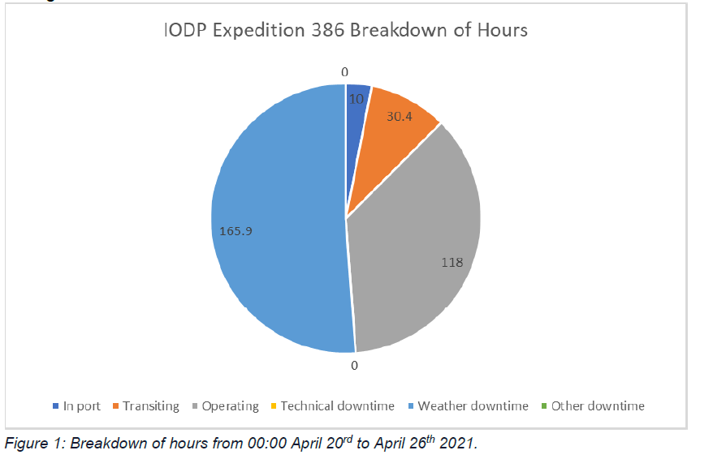

Week 3: Holes 83CD, 84A-D, 85A-D, 86AB, 87AB
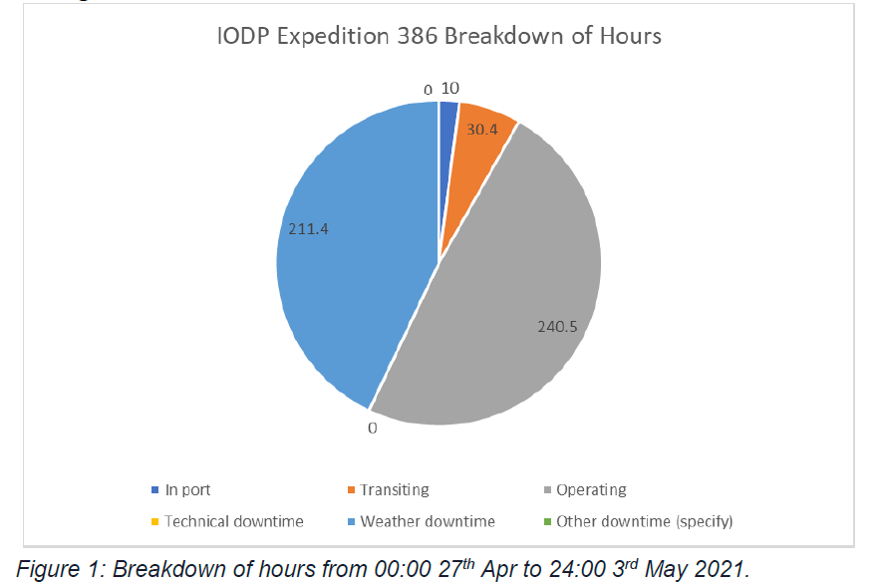

Week 4: 88A-D, 89A-D
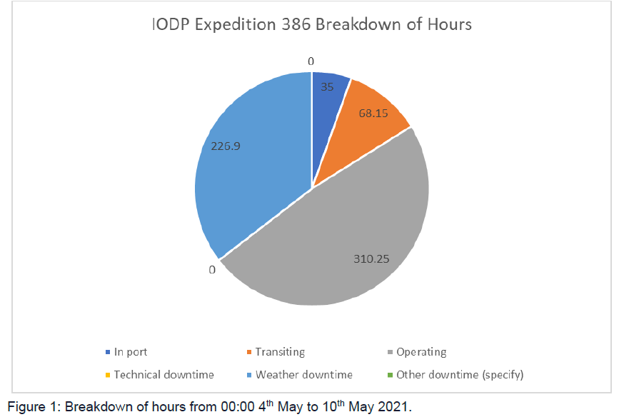

Week 5: 81EF, 82CD, 83EF, 84EF
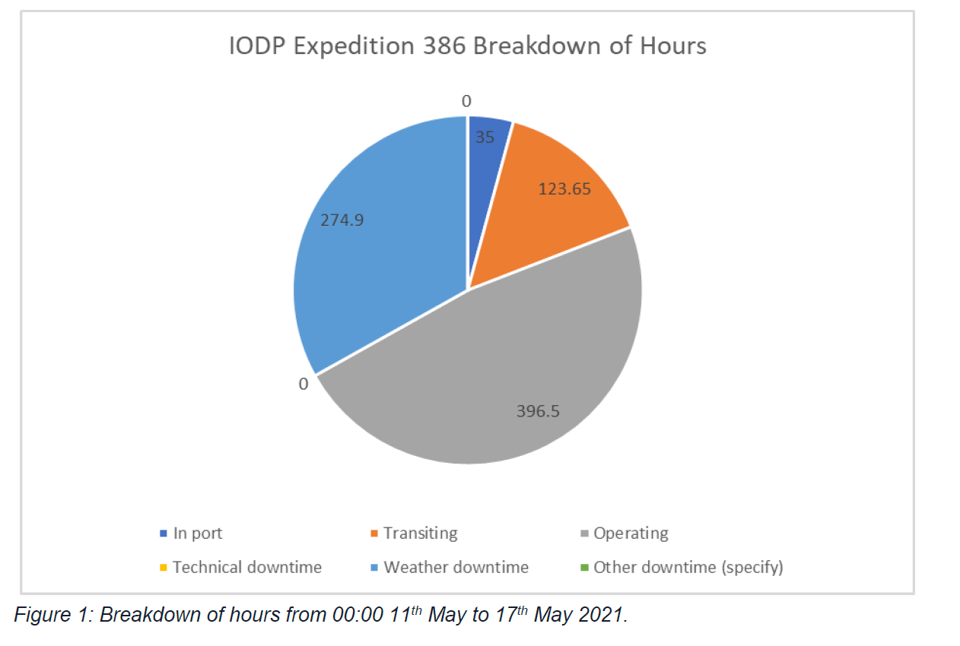

Week 6: 87CD, 90AB, 91A-D, 92AB
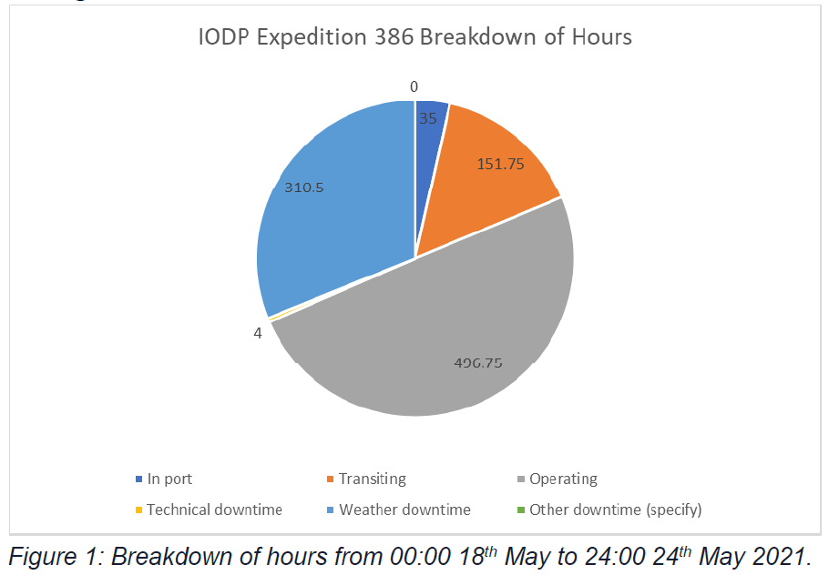

Week 7: 90CD, 92CD, 93AB, 94AB, 95AB
